“LAKE MAC” MUSKIE
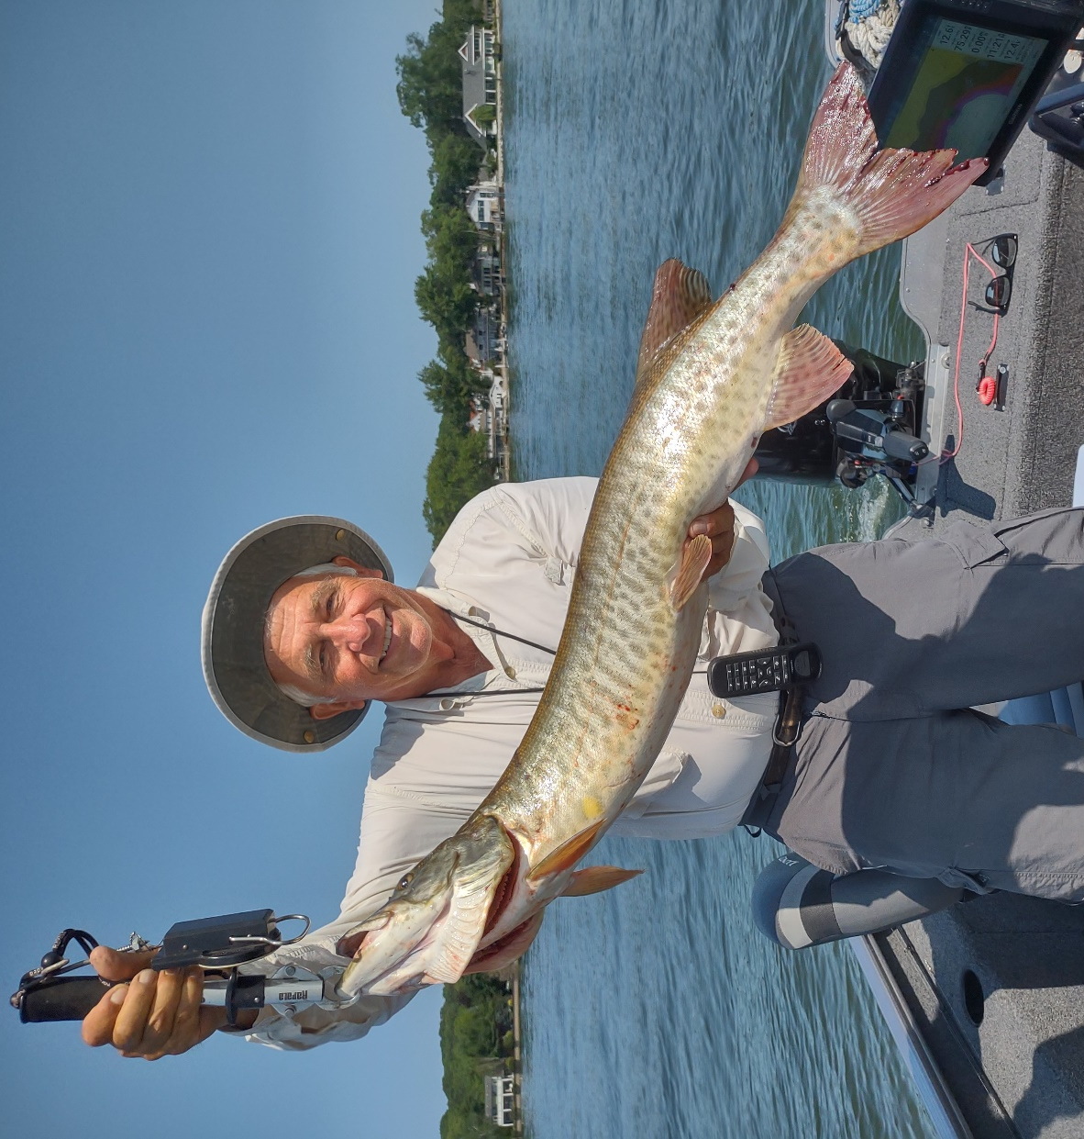
John Bouws with his first Muskie; Lake Macatawa, 7/19/23
For several years now, the Michigan DNR has been planting muskies in the drowned rivermouth lakes of Macatawa, Muskegon, White, and others connected to Lake Michigan. Not much has been heard about the muskie fishery in these lakes. I believe that it is a great untapped fishery, and that more people should be fishing these lakes for muskie. This article describes one recent experience on Lake Macatawa.

THE LAKE
Lake Macatawa is a natural fish factory. It has big populations of numerous fish species, but a reputation of mostly rough fish. That is why I think planting a top predator species like muskies in there is a good idea. Its’ dark water color of about 3 feet visibility is a positive, allowing big fish to move shallower where they are easier to catch. At times it can be quite productive for perch and other panfish. Large numbers of baitfish and predator fish can move in or out from Lake Michigan, depending on the season or weather conditions. Mostly clean, hard sandy bottom conditions allow us to use bottom-walking lures, a plus in triggering strikes from large predator species. Finally, a shallow weedline of about 5 feet rarely interferes with trolling lures on most of the lake. Numerous fishermen in the past have become frustrated with fishing “lake Mac” due to catching few large predator species (pike, musky, walleye, and smallmouth), yet it is one of my favorite lakes. Over the
years, I have caught some of my larger fish from there. This includes a 5-pound smallmouth bass, 10.5 pound walleye, 27 pound drum, 37 inch pike, 25 pound carp, and 40 inch muskie.

THE TOOLS AND AIDS
I was pleased when Lunker Hunter Club member John Bouws invited me to join him to fish Lake Macatawa. John lives on the lake and owns a 17-foot Lund ProGuide fishing boat that is stable and very comfortable to fish out of. It has a 60-horse tiller-handle outboard, which allows for more accurate trolling than a steering wheel. For electronics he uses a Garmin Ecomap Ultra Series 12-inch graph. Those tools and aids are a bit more sophisticated than what I use in my fishing, but I am always willing to look at new ideas. It was interesting how he used different colors on the Ecomap relating to the depth ranges of the different Spoonplugs (e.g., 2-4 ft-red, 4-6 feet-brown, 6-9 feet-green, etc.). It all boils down to each person using the tools and aids that help them best apply the knowledge about fish and their behavior (Spoonplugging). The newest and most expensive is not always the best, and there are many successful fishermen that use much simpler tools.

THE DAY
On Tuesday, July 19, I arrived at John Bouws house on Lake Macatawa around 9 AM. The weather was clear, sunny, and cool, so expectations were not high (cold front). Air temperatures were 65 to 75 degrees with little to no wind. We wanted to try and find out what presentations might work better on the lake. We started trolling a #250 Spoonplug (6-9 feet) along a breakline of a large bar. Going shallower might have been more thorough, but we were targeting the largest fish, and they are usually found deeper. Trolling speed was around 2-3 mph. Next, we trolled the same structure with a #200 Spoonplug which ran a little deeper (9-12 feet). By progressively trolling down, we were looking for the depth at which the fish were active. Shortly, a feisty 6-pound drum (freshwater sheepshead) grabbed the lure an put up a good fight. It helped that we walked the lure off and on the bottom as we trolled that depth. Later in the morning we started trolling there even deeper with a #100 Spoonplug (12-15 feet) and that is when the muskie hit. At first guess, John thought we just had hooked a bigger drum, but became more excited when he saw the fish! The only net in the boat was 17 inches in diameter and 24 inches deep. The key to landing a big fish with a small net is to sweep the fishes’ head and lure in the center of the net to its’ depth without touching the sides and catching the lure. Fortunately, that happened and the muskie bent his tail so we got it inside the net also. If the tail is not inside the net, big fish will use it as leverage to flip out and get away. The instant I had him in the net, the muskie flipped and the lure stuck in the net and came out of his mouth. A larger net would have made things easier. Buck Perry always emphasized that we use proper tools to match the bigger fish we are targeting. We quickly weighed, measured, and took photos before releasing it. 15 pounds and 36 inches was recorded, but the photo indicates it might have been a tad larger than that. John was excited and commented that this was the first muskie he had ever caught.

THOUGHTS ON “LAKE MAC” PRESENTATION
Trolling is a good way to learn structure, cover water, and locate fish. Systematically checking different depths makes sense as fish periodically move and change position. Although both fish were caught on the spoonplugs, we used them on 3-way rigs with a trailer flutter spoon to get a different action and more visibility in the dark water. Both fish were caught on a bright-colored lure (white). Walking a lure on and off the bottom creates lots of noise to help fish locate the lure in dark colored water. Speeds used were fast compared to most fishermen, yet we could have tried going faster than 3 mph, and might have caught more fish doing that. Large fish can swim much faster than small ones, and we are looking to trigger a reflex strike.
For more info on Spoonplugging: chasesfishes.com; You-Tube, Chase Klinesteker; ckspoonpl1@aol.com

