DON DICKSON

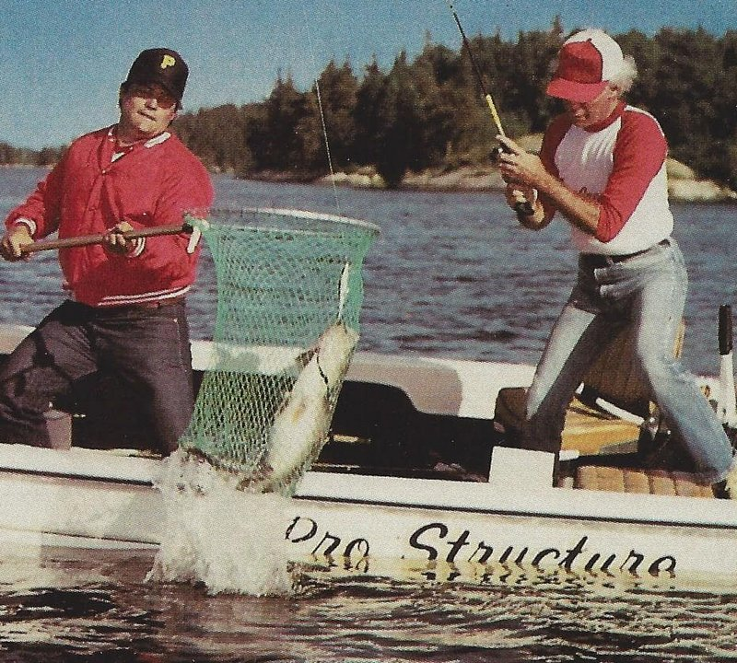

Much of what I learned about Spoonplugging was gained from classes I took from Don Dickson in the 1980’s. Don worked for Buck Perry for many years to teach and promote Spoonplugging knowledge, and he was a very effective fisherman and teacher. Recently, I found out that he is doing several instructional videos available for free on his U-Tube channel https://www.youtube.com/watch?v=7OipbKBwtU4 and have been enjoying watching them. I recommend them highly to anyone who is serious about mastering Spoonplugging.

Jim Withey, Don Stephens, Jack Clark, and myself attended several Spoonplugging schools led by Don Dickson, beginning with a 3-day lecture class in Chicago in 1980. In 1988, we convinced Don to present his class in Grand Rapids, Michigan where over 90 people attended the class. These lectures were the basis for the 7-video VCR series on Spoonplugging by Don (Pro Structure Fishing) that were sold widely. We also attended several week-long on-the-water schools held at Minaki, Canada and Thousand Island area of New York. We got to know Don well and his enthusiasm for Spoonplugging rubbed off on us.

Dons’ U-Tube video series on fishing is very thorough and on-going. It contains some past videos of his fishing and many stories related to understanding fish behavior. He gives total credit to Buck Perry for the knowledge about fish that he teaches. Check out his channel for some valuable information on fish behavior and how to catch them.

Chase Klinesteker CSI www.chasesfishes.com

